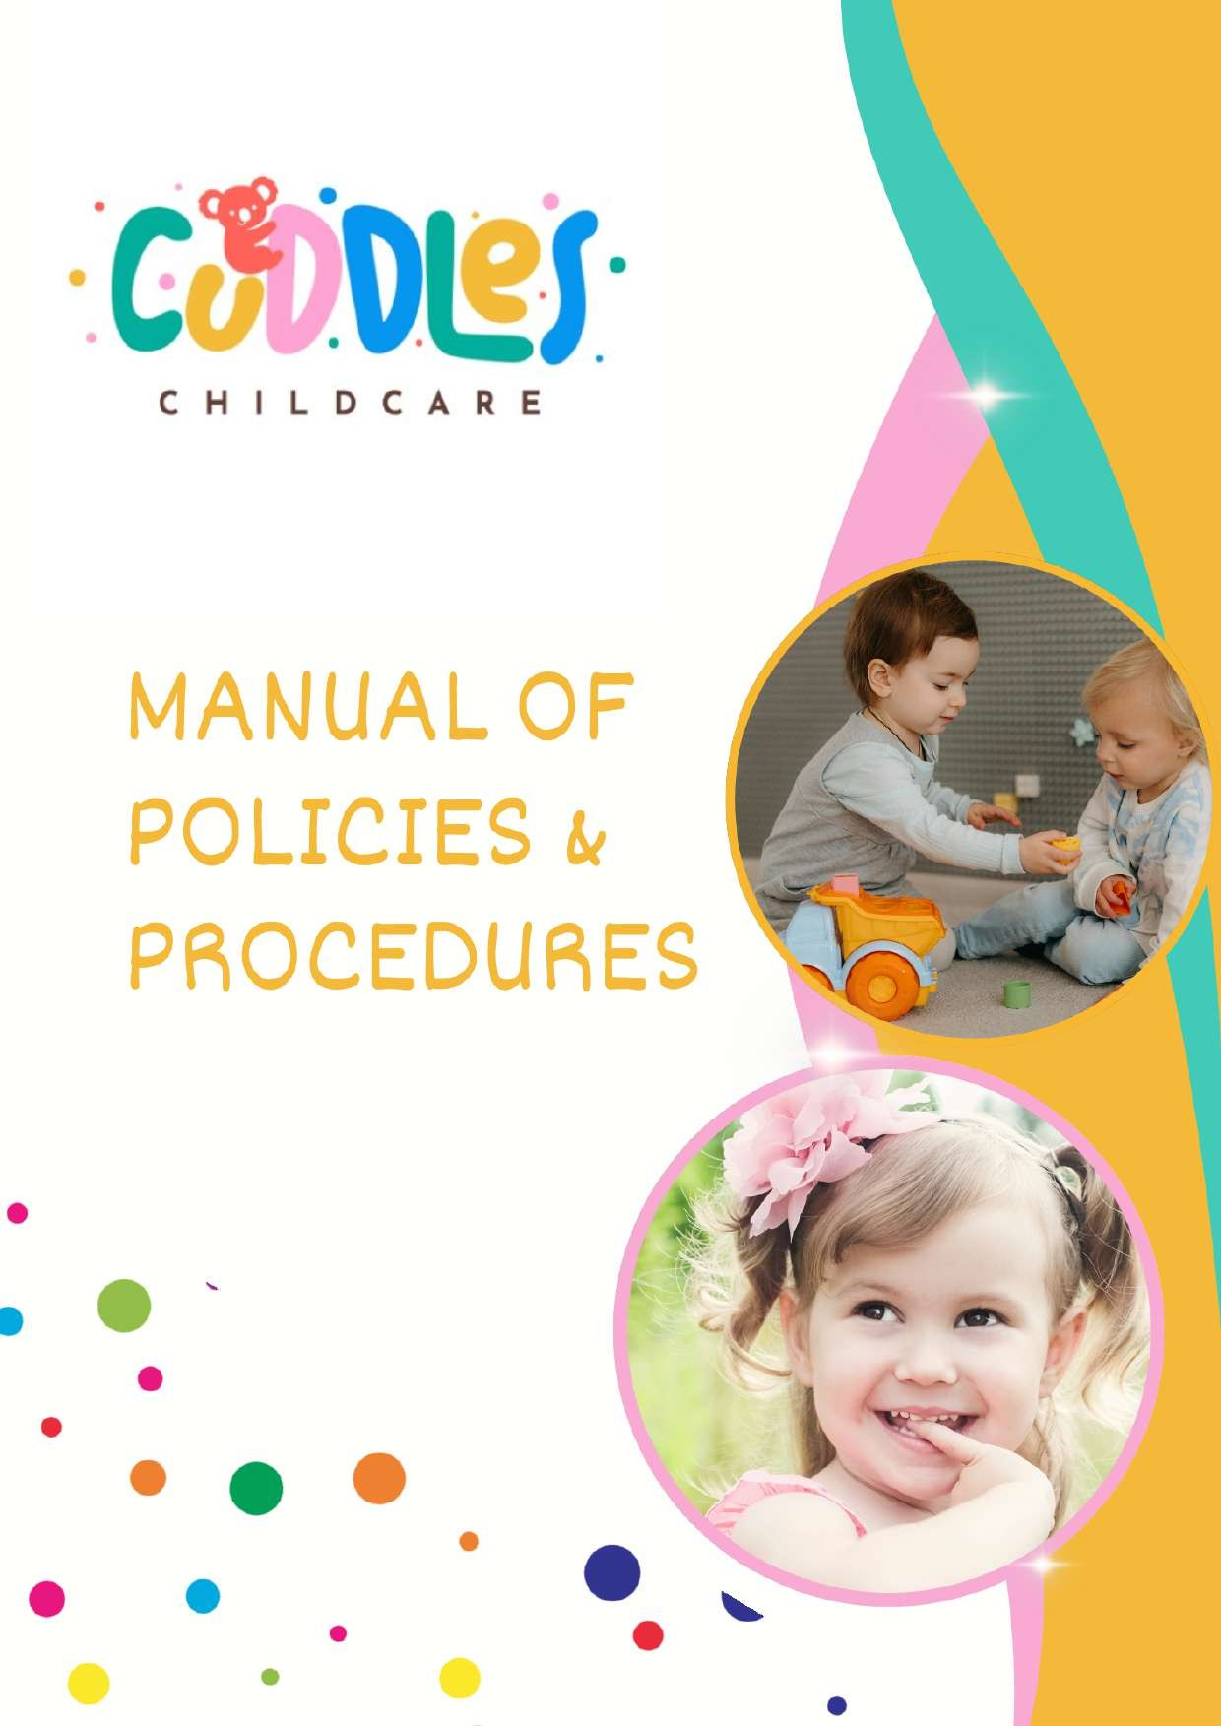

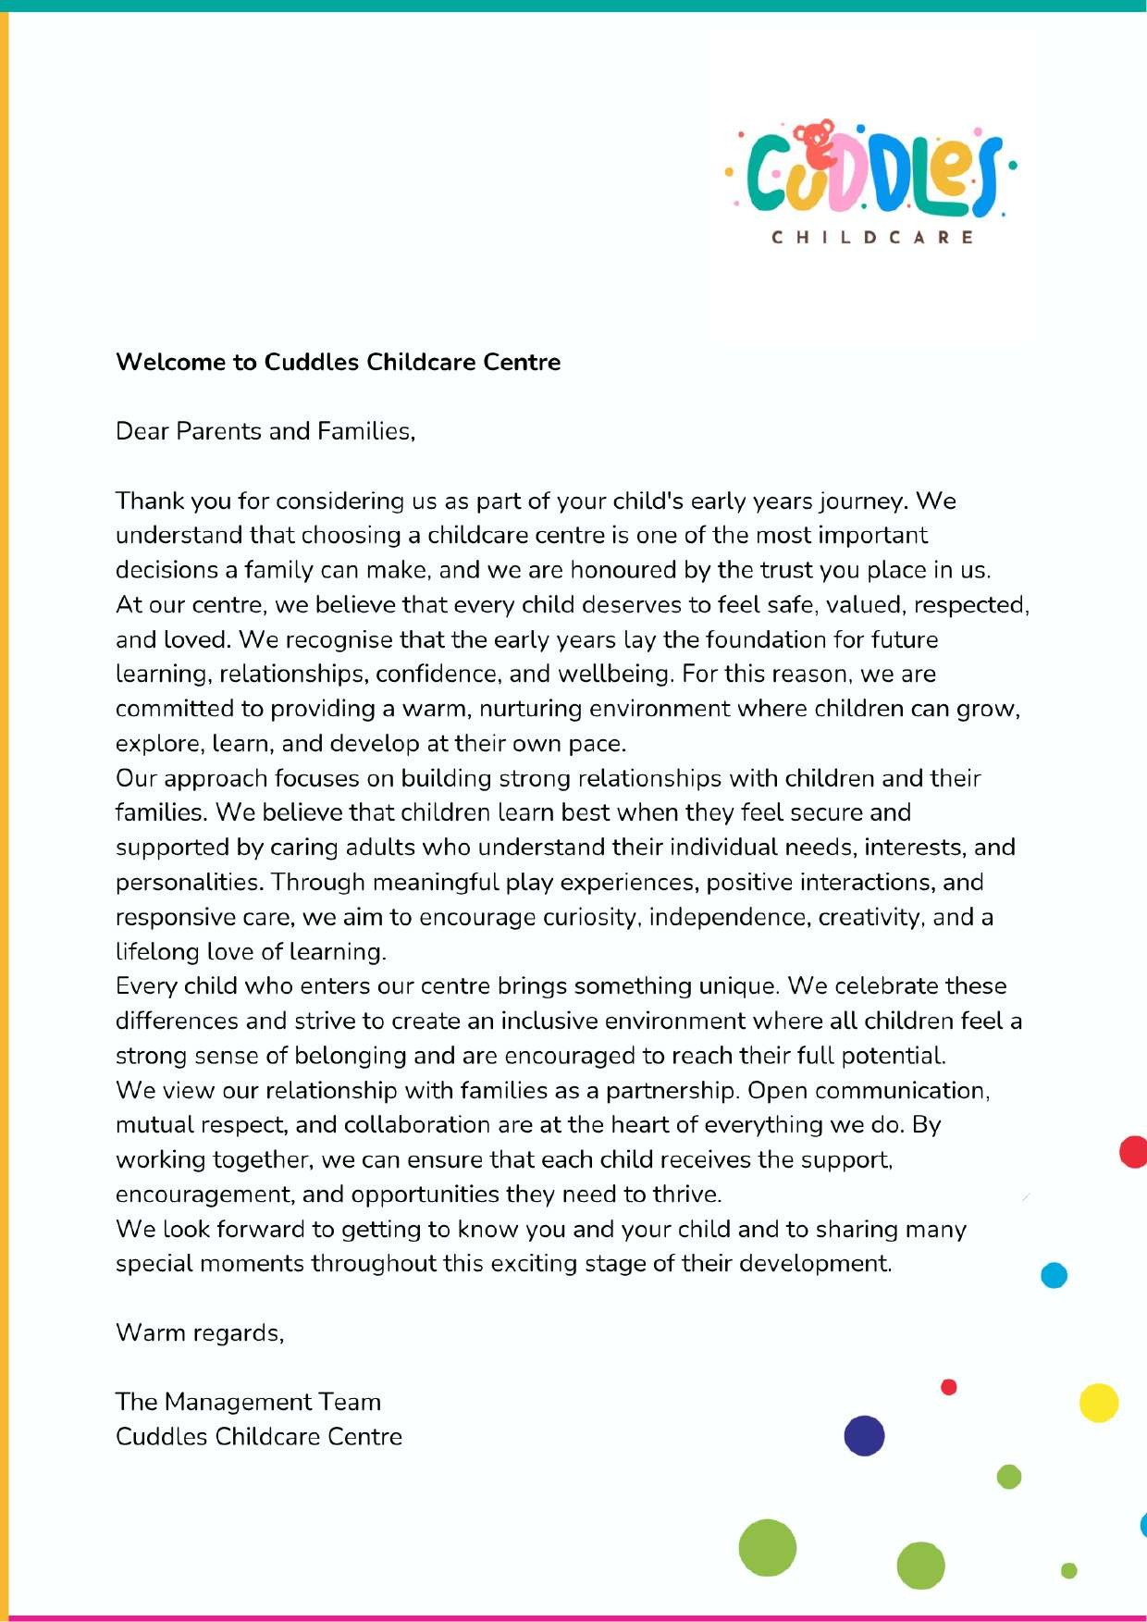

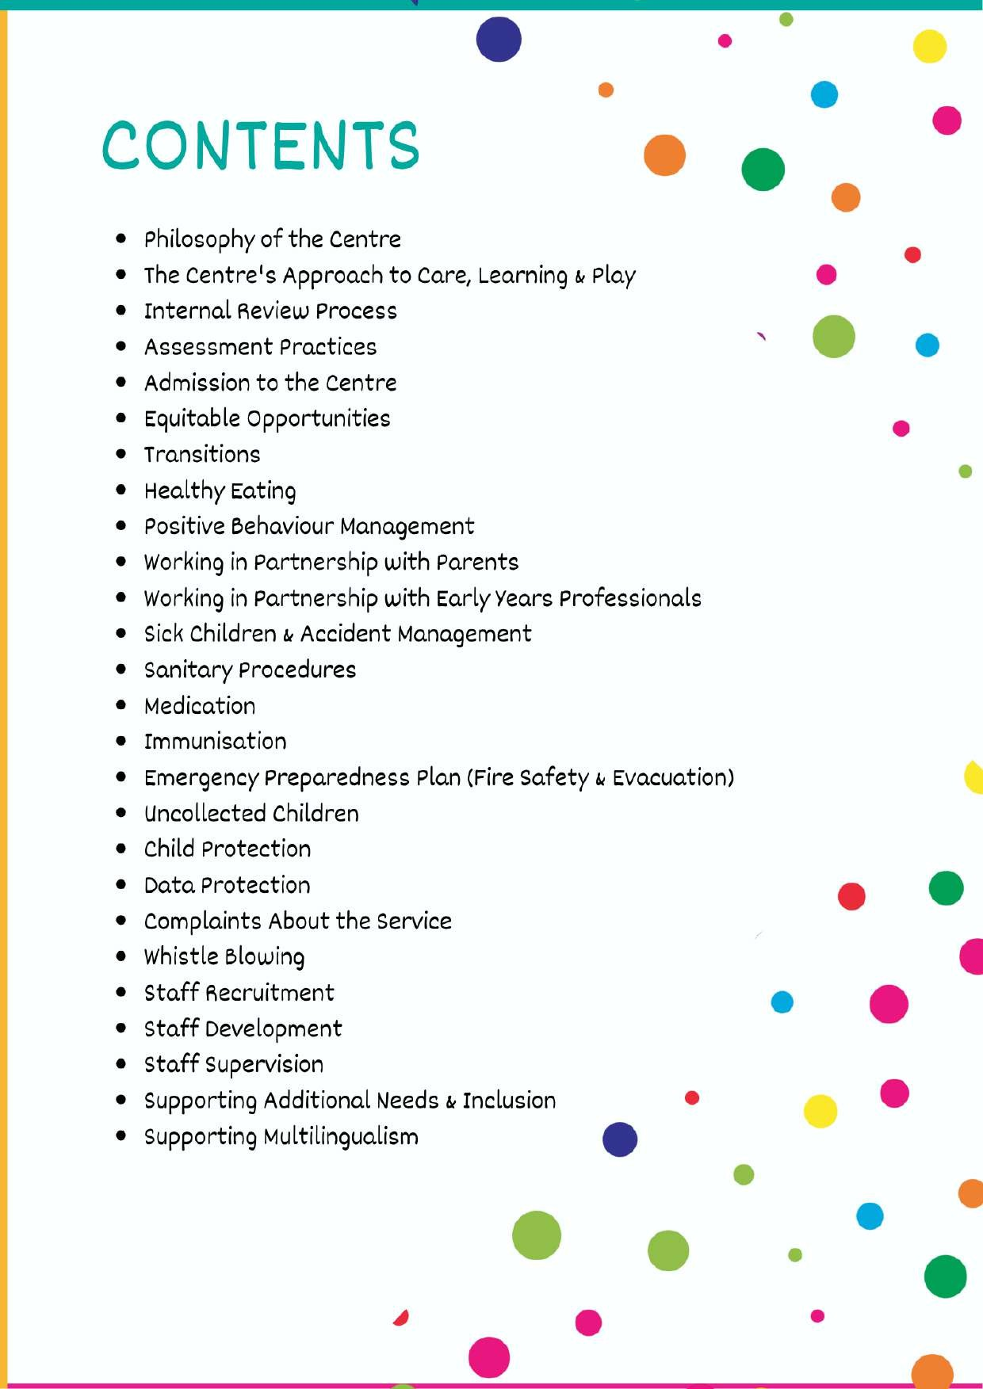

Philosophy of the Centre

At Cuddles Childcare, everything we do is guided by our commitment to placing children at the centre of their learning and development. We believe that every child is unique, capable, and full of potential. Children arrive with their own experiences, interests, ideas, and ways of understanding the world, and we value each child as an individual whose voice deserves to be listened to and respected.
We believe that children learn best through meaningful experiences, positive relationships, and opportunities to explore their environment. Learning is not something that is simply taught; it develops naturally as children investigate, create, communicate, play, and interact with others. Our role is to provide a nurturing, stimulating, and inclusive environment where children feel secure, confident, and supported to develop at their own pace.
Our approach is aligned with the Maltese Early Years philosophy and guided by the Learning Outcomes Framework (LOF). We focus on supporting the whole child rather than concentrating solely on specific skills or predetermined outcomes. We encourage the development of children's sense of identity, wellbeing, communication, social relationships, creativity, independence, and confidence as learners. The Learning Outcomes Framework provides guidance for our practice, helping us create meaningful learning opportunities that reflect children's interests, strengths, and developmental needs.
At Cuddles Childcare, we recognise that strong emotional connections form the foundation for learning. We strive to build trusting relationships with children and families, ensuring that every child feels valued, respected, and understood. We believe that genuine learning and development take place when children feel safe to explore, take risks, express themselves, and develop a positive sense of belonging.
Supporting children is not about rushing them towards milestones or achievements. It is about walking alongside them, encouraging their curiosity, celebrating their successes, and providing the guidance and reassurance they need to become confident, resilient, and lifelong learners.

Our Approach to Care, Learning and Play

At Cuddles Childcare, we view care, learning, and play as naturally connected parts of a child’s daily experience. Young children do not separate learning from play or care from development. Every interaction, experience, and routine provides opportunities for growth, discovery, and relationship building. Our approach is child-centred, play-based, and guided by the Learning Outcomes Framework, ensuring that learning develops in a meaningful and holistic way.
We believe that positive relationships are at the heart of quality early childhood education and care. Children thrive when they feel safe, respected, and valued by the adults around them. For this reason, we place great importance on creating warm and responsive relationships that help children develop a strong sense of security, belonging, and confidence within the setting.
Children are naturally curious and motivated to learn. We support this by observing their interests, listening to their ideas, and providing experiences that build on what captures their attention. Rather than directing children towards predetermined outcomes, we respond thoughtfully to their individual needs, strengths, and developmental stages, allowing learning to emerge in authentic and meaningful ways.
Play is the primary vehicle through which children learn. Through play, children explore their environment, develop their imagination, solve problems, communicate with others, and make sense of the world around them. Play provides opportunities for children to develop socially, emotionally, physically, and cognitively while enjoying the freedom to experiment, create, and discover.
The learning environment is carefully designed to encourage exploration, independence, and engagement. Our spaces are welcoming, flexible, and accessible, offering children opportunities to make choices, follow their interests, and interact with a variety of materials and experiences. We believe that the environment itself plays an important role in supporting learning and development alongside the educators who guide and nurture children's experiences.

Our Childcare Educators are attentive, reflective, and responsive professionals who support children's learning through meaningful interactions. They carefully observe

children's interests and development, providing encouragement, guidance, and opportunities that extend learning naturally. Knowing when to actively participate and when to allow children to lead their own exploration is an important part of their role.
We also recognise the value of everyday routines as important learning opportunities. Mealtimes, personal care routines, transitions, and daily interactions are approached with care and intention, supporting children's communication skills, independence, wellbeing, and social development. These moments are viewed as equally important as planned activities and contribute significantly to children's overall growth.
At Cuddles Childcare, learning is woven into every aspect of the day. Through nurturing relationships, purposeful environments, meaningful play experiences, and responsive care, we support children in becoming confident, capable, and enthusiastic learners who feel valued and empowered to explore the world around them.

Internal Review Process

At our centre, we believe that maintaining high-quality practice requires ongoing reflection, evaluation, and improvement. We are committed to regularly reviewing our provision to ensure that it continues to meet the needs of children, families, and staff while remaining aligned with current best practices and national requirements, including the Maltese Internal Review Guidelines.
Our review process is continuous and focuses on understanding the effectiveness of our daily practice. We regularly monitor the quality of the learning environment, interactions, routines, policies, and procedures to identify strengths as well as areas that may benefit from further development. This allows us to make informed decisions that enhance children's experiences and outcomes.
The views and experiences of families, children, and staff play an important role in this process. Through feedback, consultations, meetings, and ongoing communication, we

gather valuable information that helps us understand what is working well and where improvements may be needed. We value collaboration and recognise that meaningful

improvements are achieved when everyone has the opportunity to contribute their perspectives.
Professional reflection is embedded within our team culture. Childcare Educators and management work together to evaluate practice, share ideas, discuss challenges, and identify opportunities for growth. These discussions support a shared commitment to quality and help ensure that decisions are informed by both professional knowledge and practical experience.
When areas for improvement are identified, clear action plans are developed with realistic goals and timeframes. These may involve reviewing procedures, enhancing learning opportunities, strengthening communication, improving the environment, or providing additional professional development for staff. Progress is monitored and reviewed to ensure that changes are effective and contribute positively to the overall quality of the service.
Our goal is to foster a culture of continuous improvement where reflection, learning, and development are valued. By regularly evaluating our practice and remaining open to new ideas, we strive to provide a nurturing, inclusive, and high-quality environment that supports the wellbeing, learning, and development of every child.
Assessment Practices

At our centre, assessment is viewed as an ongoing process that helps us understand and support each child's individual development. It is closely linked to our daily practice and forms an essential part of how we plan, interact with children, and respond to their changing needs and interests. We believe that children demonstrate their learning in many different ways, and our role is to observe, recognise, and value these experiences as they occur naturally throughout the day.
Assessment is primarily based on careful observation of children during play, daily routines, social interactions, and learning experiences. Through these observations,

Childcare Educators gain a deeper understanding of each child's strengths, interests, abilities, and emerging skills. This information enables us to provide experiences that are meaningful, engaging, and appropriate for the child's stage of development.
Our educators use professional judgement to interpret observations and identify opportunities to support and extend children's learning. By paying close attention to how children explore, communicate, solve problems, and interact with others, we can adapt our approach to ensure that every child receives the support and encouragement they need to thrive.
Each child has an individual learning portfolio that records significant moments in their development and learning journey. Portfolios may include observations, photographs, learning stories, reflections, and planned next steps. These records are aligned with the Learning Outcomes Framework, helping us monitor progress across all areas of development while recognising that every child grows and learns at their own pace.
Partnership with families is a key element of our assessment process. We maintain open and regular communication with parents through daily conversations, updates, and opportunities for more formal discussions when required. Families provide valuable insights into their child's experiences, interests, and achievements outside the setting, allowing us to develop a more complete understanding of each child's development.
Assessment at our centre is not about measuring children against fixed expectations or comparing them to others. Instead, it is about building a holistic picture of each child, celebrating their achievements, recognising their individuality, and using this knowledge to create meaningful opportunities for further learning and development. Through reflective and responsive assessment practices, we ensure that every child receives support that is tailored to their unique strengths, needs, and potential.

Admission to the Centre

We understand that choosing a childcare service is an important decision for families, and we are committed to making the enrolment process as straightforward, welcoming, and supportive as possible.
Our centre provides care for children aged 3 months to 3 years and operates from Monday to Friday between 6:30 am and 6:30 pm, and on Saturdays from 8:00 am to 4:00 pm. The centre remains closed on Sundays and public holidays. Families receive an annual calendar outlining all scheduled closures and important dates throughout the year.
Enrolment is subject to the availability of places within the appropriate age group. Once a place is offered, parents are provided with all necessary information regarding registration requirements and timelines. To confirm a placement, families must complete the enrolment process, submit the required documentation, and pay the applicable non-refundable registration fee.
As part of the registration process, parents will be asked to provide information relating to their child, including identification documents, emergency contact details, medical information where relevant, and any additional records required to ensure the child's wellbeing and safety within the setting.
To support children's participation in the daily programme and help them settle comfortably into the environment, families are encouraged to arrive by 8:30 am whenever possible. This allows children to take part in group experiences, routines, and learning opportunities from the beginning of the day. We understand that individual family circumstances may vary and will always aim to accommodate reasonable arrangements where needed.
Effective communication between families and the centre is highly valued. To support this partnership, we utilise a digital communication platform through which parents can receive updates about their child's day, access important announcements, and stay informed about events, reminders, and centre information.
Our goal is to ensure that every child and family experiences a positive, welcoming, and well-supported start to their journey with us.

Induction and Transition into the Centre

Starting childcare is a significant milestone for both children and their families. We are committed to ensuring that this transition is positive, supportive, and tailored to the individual needs of each child.
Before a child begins attending the centre, families are invited to attend an induction meeting. This meeting provides an opportunity for parents to become familiar with the environment, meet the Childcare Educators, learn about daily routines, and share important information about their child's interests, preferences, developmental needs, and care requirements. Establishing this partnership from the outset helps us provide a smooth and personalised transition experience.
We understand that children adjust to new environments in different ways and at different rates. For this reason, we implement a gradual settling-in process that is responsive to each child's individual needs. Initial visits may be shorter in duration, with attendance increasing gradually as the child becomes more confident and comfortable within the setting. This approach allows children to become familiar with the environment, routines, peers, and educators in a way that promotes a sense of security and belonging.
Throughout the transition period, we maintain regular communication with families to share observations, discuss progress, and address any concerns that may arise. By working closely together, we can ensure that each child receives the support and reassurance they need during this important stage.
Our aim is to create a welcoming and nurturing experience that helps children develop positive relationships, build confidence in their new surroundings, and establish a strong foundation for future learning and development within the centre.

Preparing for Your Child’s First Day

Beginning childcare is an exciting new chapter, and a little preparation can help make the experience smoother and more comfortable for both children and parents. Taking time to prepare in advance can support children in feeling more confident, secure, and ready to explore their new environment.
We encourage families to talk positively about the centre before the first day and, where appropriate, involve their child in simple preparations such as choosing or packing items for their bag. These small steps can help children develop familiarity with the upcoming change and ease any feelings of uncertainty.
To support your child's comfort and wellbeing throughout the day, all personal belongings should be clearly labelled with the child's name. Children should arrive with any items required for their daily care, including spare clothing, nappies and wipes where applicable, comfort items if needed, and any other essentials discussed during the induction process.
Children should be dressed in comfortable, practical clothing that allows them to move freely, participate in play experiences, and explore both indoor and outdoor environments. Suitable footwear is also recommended to support active play and physical development.
By preparing together and maintaining a positive and reassuring approach, families can help children feel settled and ready to begin building new relationships, discovering new experiences, and enjoying their time at the centre.

Equitable Opportunities

At our centre, we are committed to creating an inclusive environment where every child is valued, respected, and given the opportunity to reach their full potential. We recognise that children come from diverse backgrounds and bring with them unique experiences, strengths, interests, abilities, and ways of learning. These differences are embraced and celebrated as an important part of our community.

We believe that providing equitable opportunities means recognising and responding to the individual needs of each child. Rather than treating every child in exactly the same way, we adapt our practices, environments, and experiences to ensure that all children can participate meaningfully and confidently in daily life at the centre.
Our Childcare Educators work closely with children and families to understand individual circumstances and provide appropriate support where needed. We strive to remove barriers to participation and create learning experiences that are accessible, engaging, and responsive to the diverse needs of the children in our care.
Respect for diversity is promoted through everyday interactions, learning experiences, resources, and positive role modelling. Children are encouraged to develop an appreciation of different cultures, family structures, languages, abilities, and perspectives while building a strong sense of their own identity and belonging.
We believe that every child has the right to feel included, supported, and capable. By fostering an environment that values fairness, respect, and individuality, we help children develop confidence, positive relationships, and a sense of belonging within the centre and the wider community.
Through our commitment to equitable practice, we aim to ensure that all children have access to meaningful opportunities for learning, play, exploration, and development, allowing them to thrive in a safe, welcoming, and supportive environment.

Transitions
At our centre, we recognise that transitions are important experiences in a child's life and can bring a range of emotions for both children and their families. We are committed to ensuring that all transitions are planned carefully and managed in a way that promotes children's wellbeing, confidence, and sense of belonging.
The transition into childcare begins before a child attends their first session. Families are invited to visit the centre, meet the Childcare Educators, and become familiar with the environment, routines, and daily experiences. These initial opportunities help build positive relationships and create a foundation of trust between the child, family, and educators.

We understand that every child adjusts differently to new situations and environments. For this reason, we implement a flexible settling-in process that is tailored to the individual child. Attendance may begin with shorter visits and gradually increase as the child becomes more comfortable and secure. Throughout this period, educators work closely with families, sharing information and providing reassurance to ensure that the transition is as smooth and positive as possible.
Building strong and trusting relationships is central to successful transitions. Our educators provide consistent, responsive, and nurturing support, helping children develop confidence in their new surroundings and encouraging them to engage with their environment, peers, and daily experiences at their own pace.
As children prepare to move to the next stage of their educational journey, including Kindergarten or another educational setting, we provide opportunities that help them become familiar with the upcoming change. Through discussions, stories, role play, and age-appropriate activities, children are supported to develop confidence and understanding about what to expect.
Where appropriate and with parental consent, relevant information may be shared with the receiving setting to support continuity of care and learning. This helps ensure that children's individual needs, strengths, interests, and developmental progress are understood and can continue to be supported effectively.
We work in partnership with families throughout all transition periods, recognising that positive collaboration contributes significantly to children's emotional wellbeing and successful adjustment. For children requiring additional support, individualised strategies are implemented to ensure that every transition is managed in a way that promotes security, inclusion, and positive outcomes.

Healthy Eating

At our centre, food is part of care, not just routine. Eating habits begin early, and the experiences children have with food shape their relationship with it over the long term. We promote a balanced and varied approach to nutrition, supporting children in experiencing a wide range of foods that contribute to their growth and well-being.

Fresh foods, such as fruits and vegetables, are encouraged daily, and water is recommended as the primary drink throughout the day.

We are intentional about reducing exposure to highly processed, sugary foods and drinks. This is not about restricting children for the sake of rules, but about supporting them in developing healthier preferences over time. Mealtimes are calm, social, and unhurried. Children are encouraged, but never pressured, to try new foods. These moments are used to build independence, communication, and a positive relationship with eating.

Packed Lunch Guidance

We work in partnership with families to support healthy and safe eating. Parents are asked to provide balanced meals that include a mix of nutritious options such as sandwiches, fruit, vegetables, dairy, or other appropriate items.

To maintain a safe environment for all children, the following expectations apply:
- Sugary snacks and drinks are not permitted
- Nuts are not allowed due to allergy risks
- Food must be prepared in a way that reduces choking hazards
- Containers should be practical and non-breakable
- All items must be clearly labelled

If food is not considered safe for consumption, for example, due to choking risk, it will not be given to the child. This is a safety measure, not a preference.

Allergies and Dietary Needs

Children’s health and safety are a priority. Any allergies, intolerances, or dietary requirements must be clearly communicated before the child starts at the centre.

Where necessary, individual care plans are put in place to ensure needs are managed safely and consistently. Required medication must be provided and kept up to date. We work closely with families to ensure all dietary needs are understood and respected, while maintaining a safe environment for all children. Celebrations are kept simple, inclusive, and mindful of children’s well-being. Families may choose to provide a cake or cupcakes; however, these should be low in sugar and suitable for young children. Celebrations are conducted in a way that is safe, manageable, and considerate of the group's dietary needs. The focus remains on recognising the child, rather than on food or excess.

Positive Behaviour Support

At our centre, behaviour is understood as communication. Young children are still learning how to express their needs, manage emotions, and navigate relationships, and this development takes time, guidance, and consistent support. Our approach is rooted in connection. When children feel emotionally safe, understood, and supported, they are more able to regulate themselves and engage positively with others. For this reason, we prioritise strong, responsive relationships as the foundation of behaviour support.

Childcare Educators provide clear, consistent boundaries alongside warmth and care. They use calm language, simple explanations, and modelling to guide children towards safe and respectful behaviour. The focus is always on teaching and supporting, rather than controlling or punishing. When challenges arise, we take a step back to understand what the behaviour may be communicating. This may relate to unmet needs, frustration, limited communication skills, or environmental factors. Observations are used to identify patterns, and practice is adjusted accordingly. This may include adapting routines, modifying the environment, or strengthening adult support during key moments.

Consistency across the team is essential. All Childcare Educators follow a shared approach to ensure children experience predictable, secure responses. We work in partnership with families throughout. Where behaviours are ongoing or more complex, we collaborate with parents and, where appropriate, involve external professionals to ensure the child receives the right support. Our priority is to support each child’s development while maintaining a safe, respectful environment for everyone.

Biting Behaviour

Biting is a behaviour that can occur in early childhood, particularly as children develop communication skills and learn to manage strong emotions. While it can be part of development, it is addressed immediately to ensure the safety and well-being of all children.

If a biting incident occurs, the child who has been hurt is supported first, receiving comfort and any necessary first aid. The child who has bitten is then calmly guided to understand what has happened, using clear and simple language appropriate to their age. Incidents are recorded, and both families are informed respectfully and confidentially.

We do not label, shame, or punish children. Instead, we focus on understanding the cause of the behaviour. Childcare Educators observe closely to identify possible triggers, such as frustration, tiredness, overstimulation, or difficulty communicating. Based on this, adjustments are made to better support the child. When biting becomes repeated, a more targeted approach is implemented. This may include increased supervision, changes to the environment, and additional support strategies to help the child develop alternative ways of expressing themselves. We work closely with parents to ensure a consistent approach between home and the centre. If needed, further guidance from specialists may be recommended. Our approach remains supportive while ensuring the safety of all children.

Working in Partnership with Parents

At our centre, relationships with families are central to everything we do. Parents are not separate from the process, they are part of it. We value open, honest, and respectful communication. Daily exchanges, ongoing conversations, and regular updates ensure that parents remain informed and connected to their child’s experiences.

We also recognise that parents bring essential knowledge about their child. Their insights, observations, and concerns are taken seriously and contribute to how we support each child within the setting. By working together, we create consistency between home and the centre. This helps children feel secure, understood, and supported across both environments.

Working in Partnership with Early Years Professionals

Supporting children effectively often requires collaboration beyond the centre. We work alongside other professionals where needed, including early years specialists, therapists, and support services. This allows us to build a deeper understanding of each child and respond appropriately, particularly when additional needs are identified.

Partnership working ensures that support is consistent, informed, and focused on the child’s overall well-being and development. We also value connections within the wider community, recognising that these can enhance both children’s experiences and the support available to families.

Commitment to Professional Development

Quality practice depends on knowledgeable and reflective Childcare Educators. At our centre, we are committed to continuous professional development. Staff regularly

engage in training, workshops, and further learning to stay informed about current approaches in early childhood education. This ongoing development strengthens practice, supports consistency across the team, and ensures that decisions are informed by both experience and evidence. Reflection is also part of this process. Childcare Educators are encouraged to think critically about their work, adapt as needed, and continuously improve the quality of care and learning they provide.

Sick Children

The health and well-being of all children and staff are a priority. Maintaining a safe environment requires clear and consistent expectations around illness. Children should not attend the centre if they are unwell or unable to participate comfortably in daily activities. This includes symptoms such as fever, vomiting, diarrhoea, persistent coughing, unusual fatigue, or any condition that may affect their well-being or that of others.

If a child becomes unwell during the day, parents will be contacted and are expected to arrange prompt collection. As a general guideline, children should remain at home until they have been symptom-free for at least 24 hours without medication. In cases of vomiting or diarrhoea, this 24-hour period begins after the last episode. For fever, children must be fever-free for at least 24 hours without medication before returning.

For contagious conditions, including infections, rashes, or illnesses that can spread easily, children must remain at home until they are no longer infectious. Where necessary, medical advice should be sought to confirm when it is safe to return. Parents are required to inform the centre of any illness, diagnosis, or condition that may affect their child or others. This includes allergies, ongoing health conditions, and contagious illnesses.

In some cases, a medical certificate may be requested before the child returns, particularly following a contagious illness or where there are concerns regarding the

child’s health. Up-to-date contact details must always be provided to ensure parents can be reached quickly if needed. By working together, we can maintain a healthy, safe, and supportive environment for all.

Sanitary Practices

At our centre, health and hygiene are treated as part of everyday practice, not as separate tasks. A clean and well-maintained environment supports children’s well-being, reduces the spread of illness, and creates a space where children can explore safely. Daily cleaning routines are carried out consistently, with particular attention given to high-contact areas, shared resources, and care spaces. Toys, equipment, and materials are regularly cleaned, checked, and maintained to ensure they remain safe and appropriate for use. The environment is monitored throughout the day to ensure standards are maintained.

We work in partnership with families to support these practices. All items brought into the centre, including bottles, lunch boxes, clothing, and bedding, must be clean and clearly labelled. This helps prevent cross-contamination and supports a hygienic environment for all children. Personal care routines are handled with respect and professionalism. Nappy changing is carried out using hygienic procedures that prioritise both safety and dignity. Children’s privacy is maintained at all times. Parents are responsible for providing all necessary items, and communication is maintained where supplies are low or where any concerns, such as skin irritation, arise.

Toilet training is approached collaboratively, recognising that children develop at different rates. Childcare Educators support children patiently and consistently, working alongside families to ensure a shared approach between home and the centre. Hand hygiene is embedded in the daily routine. Children are supported to wash their hands at key times, including on arrival, before and after meals, after toileting, and following messy play. Childcare Educators guide children in developing these habits in ways appropriate to their age and understanding.

Parents are expected to ensure that children arrive clean and well cared for. This includes maintaining basic hygiene such as clean clothing, tied-back hair where appropriate, and short, clean fingernails to support both hygiene and safety. Where head lice are identified, parents must inform the centre. Children should remain at home until appropriate treatment has been completed. Families will be informed where necessary, with confidentiality maintained at all times. The centre complies with all relevant local health, safety, and sanitation requirements, with regular checks and maintenance to ensure a consistently safe environment.

Medication

At our centre, the administration of medication is approached with caution to ensure children’s safety. Medication is not routinely administered by staff. Where possible, parents or guardians are expected to attend the centre to administer medication themselves.

Any medication given to a child before arrival must be clearly communicated to staff. This is essential to ensure accurate monitoring of the child’s condition and to avoid risk. Children who are unwell should not attend the centre. If a child becomes unwell during the day, parents will be contacted and expected to collect them promptly. In exceptional cases where medication is required on an ongoing basis, arrangements may be considered in consultation with management. This will only take place with clear written consent, appropriate medical guidance, and a defined procedure in place.
Immunisation

Parents are required to provide up-to-date immunisation records before their child starts at the centre. These records must be kept up to date, and any updates should be communicated to the centre. Maintaining accurate immunisation information supports the health of all children and helps reduce the risk of preventable illness within the setting.

Accident Management

While every effort is made to maintain a safe environment, we recognise that minor accidents can occur as part of children’s natural exploration and development. If an accident occurs, the child is attended to immediately by a trained member of staff. First aid is administered where required, and the child is supported and comforted.
Parents are informed as soon as possible, and a written accident report is completed. This includes details of the incident and any action taken. Parents are asked to review and sign the report to confirm they have been informed. In the case of a more serious incident, parents are contacted immediately. Where necessary, emergency services will be contacted without delay to ensure the child receives appropriate care. Consent for emergency treatment is obtained during enrolment.

Ongoing Communication and Safety

Clear communication is essential to maintaining a safe environment. Parents are expected to inform the centre of any injuries or incidents that occur outside of the setting. This allows staff to provide appropriate care and maintain accurate records.

Where a child has been unwell or injured, the centre may request that the child remain at home until they are well enough to participate safely and comfortably in daily activities. Maintaining open communication between home and the centre ensures that children’s needs are understood and supported consistently.

Emergency Preparedness Plan (Fire Safety and Evacuation)

At our centre, emergency preparedness is taken seriously, with clear procedures in place to ensure the safety of all children and staff. The centre is equipped with appropriate fire safety systems, including alarms, detection systems, and fire-fighting equipment. These are regularly checked and maintained in line with safety requirements.

Staff are trained in emergency procedures and understand their roles during an evacuation. Regular fire drills are conducted to ensure that both staff and children are familiar with the process and can respond calmly. If an alarm is activated, children are guided out of the building immediately using designated evacuation routes. All areas are checked to ensure no one remains inside. A daily attendance record is used to confirm that all children and staff are accounted for once outside.

A designated assembly point is used, where headcounts are carried out. If there are any concerns, emergency services are contacted without delay. Emergency contact details and first aid supplies are always accessible. Evacuation procedures are clearly displayed throughout the centre to ensure awareness among staff and visitors. These measures ensure that, in the event of an emergency, responses are immediate, organised, and focused on keeping everyone safe.

Uncollected Children

At our centre, children are only released into the care of authorised individuals. This is a non-negotiable part of safeguarding. Parents are required to provide clear details of all authorised persons permitted to collect their child. Children will only be released to those named, and identification may be requested where necessary. If collection arrangements change, parents must inform the centre in advance so this can be verified safely.

Children should be collected at the agreed time. Predictable routines support children’s sense of security and help them feel settled at the end of the day. If a delay occurs, parents are expected to inform the centre as soon as possible. During this time, the child will continue to be appropriately supervised and cared for.

Where late collection becomes a pattern without a valid reason, the centre may take further action in line with agreed terms and conditions. If a child is not collected and attempts to contact parents and emergency contacts are unsuccessful, safeguarding

procedures are followed. This may include contacting the relevant authorities to ensure the child’s safety. At all times, decisions are made in the best interest of the child.

Child Protection

At our centre, safeguarding is embedded in everyday practice. The safety, dignity, and well-being of the child are central to all decisions and actions.

All staff are trained to recognise signs that may indicate a concern regarding a child’s welfare. This includes changes in behaviour, physical indicators, or anything that raises concern about a child’s safety or well-being. Any concern, no matter how small, is taken seriously. Staff are required to report concerns immediately to management, and accurate records are maintained. Concerns are managed in line with national safeguarding procedures, and where necessary, referred to the appropriate authorities.

Confidentiality is maintained at all times. Information is shared only with those who are authorised and directly involved in safeguarding processes, in line with legal and professional requirements. Where a child presents with an injury or concerning signs, staff may seek clarification from parents or caregivers in a sensitive and professional manner. Observations are recorded factually, without assumption, and followed up as required. Our responsibility is to act in the best interest of the child at all times. This includes taking appropriate action where there are concerns, even where this may be difficult.

Data Protection

At our centre, personal information is handled with care, respect, and responsibility. We collect and maintain essential information to support children’s care, safety, and development. This includes registration details, emergency contacts, medical

information, authorised collection records, and documentation related to the child’s experiences within the setting.

All data is stored securely and accessed only by authorised staff when required. Measures are in place to prevent unauthorised access, loss, or misuse of information. Personal data is not shared with third parties unless required by law or with the explicit consent of parents. We ensure that all data-handling practices comply with current data protection regulations and reflect a commitment to confidentiality and professional integrity.

Social Media Photography

Images may be taken within the centre as part of documenting children’s experiences, learning, and development. These are used to support communication with families and provide insight into the child’s day. All images are shared through secure and appropriate channels. Written parental consent is required for any use of images beyond internal communication, including social media or promotional materials.

Consent is optional and can be withdrawn at any time. While the centre takes all reasonable steps to ensure images are used appropriately, it is important to recognise that once images are shared on public platforms, control over their use cannot be guaranteed. Parents are encouraged to consider this carefully when providing consent.

Use of Personal Data

All personal information and images are used strictly for purposes related to the child’s care, communication with families, and the safe and effective operation of the centre. We do not use or share data beyond what is necessary. All information is handled respectfully, securely, and in line with legal obligations. Our approach ensures that

children and families are protected, while maintaining transparency and trust in how information is managed.

Complaints About the Service

At our centre, feedback is seen as an important part of maintaining and improving the quality of our service. We encourage open, respectful communication and aim to address concerns in a fair, timely, and transparent way. Most concerns can be resolved through direct discussion. Parents are encouraged to speak with a member of staff or arrange a meeting with management where more time or clarity is needed. We aim to listen carefully, understand the concern, and respond in a constructive, solution-focused way.

Where a concern cannot be resolved informally, a formal complaint may be submitted in writing. This will be reviewed by management, with appropriate steps taken to investigate and respond. The outcome will be communicated clearly to the parent, along with any actions taken. If a parent feels that their concern has not been resolved satisfactorily, they have the right to escalate the matter to the Directorate for Quality and Standards in Education (DQSE) for further guidance and support. Our approach ensures that concerns are taken seriously, handled respectfully, and used as an opportunity to strengthen practice.

Whistleblowing

At our centre, safeguarding is everyone’s responsibility. Creating a safe environment for children depends on a culture where concerns can be raised without hesitation. All staff have a duty to report any concerns relating to unsafe practice, inappropriate behaviour, or anything that may place a child at risk. Concerns should be raised directly with management and will be handled confidentially and professionally.

Reports are taken seriously and acted upon promptly. This may involve further investigation, internal review, or referral to external professionals or authorities where required. The focus is always on protecting children and ensuring that standards of care and conduct are upheld. Parents are also encouraged to raise any concerns about practice or the environment. Where concerns cannot be resolved at the centre level, they may be referred to the appropriate authorities, including Child Protection Services.

All individuals who raise concerns are supported. The centre promotes a culture of accountability, where speaking up is recognised as a necessary and responsible action to protect children and maintain professional standards.

Staff Recruitment

At our centre, the quality of care provided to children is directly linked to the quality of the team. Recruitment is therefore approached with care, structure, and clear expectations. All staff are selected through a structured recruitment process. Vacancies are advertised through appropriate channels, and candidates are shortlisted based on relevant qualifications, experience, and suitability for working with young children.

The selection process includes interviews that assess both professional knowledge and the ability to engage with children in a responsive, respectful, and developmentally appropriate way. Successful candidates are required to provide all necessary documentation prior to employment. This includes recognised qualifications in early childhood education, a valid Police Conduct Certificate, Protection of Minors clearance (POMA), and any additional required certifications such as Paediatric First Aid and Food Handling. References are also obtained and verified.

All new staff complete a probationary period. During this time, their practice, interactions with children, and overall professionalism are monitored and supported to

ensure they meet expected standards. Childcare Educators are expected to demonstrate not only knowledge and skills, but also the attitudes required to work effectively in an early years setting. This includes the ability to build positive relationships, communicate clearly, and work collaboratively as part of a team.

The centre operates in line with all regulatory requirements, including maintaining appropriate child-to-educator ratios, to ensure children receive consistent care, attention, and support within a safe environment.

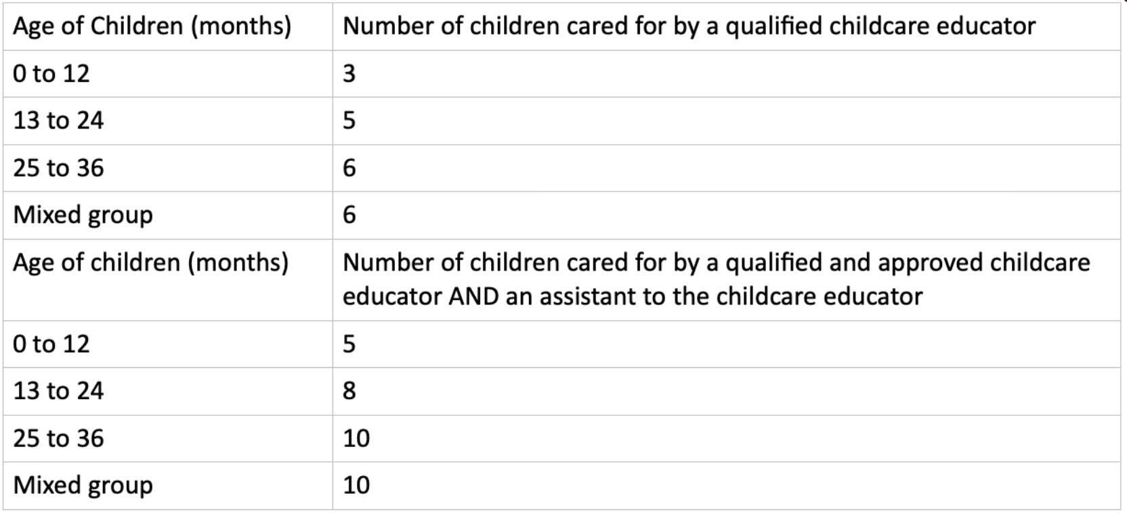
Child to Childcare Educator Ratios

Staff Development

At our centre, the quality of our practice depends on the strength of our team. For this reason, professional development is not treated as optional, but as an ongoing and essential part of our work. Childcare Educators are supported to continuously develop their knowledge, skills, and understanding of early childhood practice. This includes participation in both external training and internal development opportunities. Mandatory certifications, such as Paediatric First Aid and Food Handling, are maintained and regularly updated, alongside ongoing training in safeguarding, health and safety, and child development.

Professional growth is also supported through reflective practice. Regular team meetings provide space to share ideas, review experiences, and ensure consistency across the setting. These discussions focus not only on what is being done, but on why it is being done, strengthening professional judgement across the team. Individual support is provided through ongoing supervision and one-to-one discussions. These sessions allow staff to reflect on their role, receive feedback, and identify areas for development. Formal reviews are also used to set clear goals and support progression over time. We promote a working environment where staff feel able to ask questions, seek support, and contribute ideas. Open communication and shared responsibility strengthen both team culture and the quality of practice provided to children.

Student Placements

As part of our role in the early years sector, we support students undertaking early childhood education studies by offering structured placement opportunities. Students are always supervised by qualified staff and are not left alone with children at any time. Their role is to observe, support, and gain practical experience within a professional setting.

Parental consent is obtained prior to the start of any placement. Students are required to follow all centre policies, including those related to confidentiality and data protection. The use of personal devices for photography or recording is strictly prohibited. Placements are approached as learning experiences, with guidance provided to help students understand professional practice in real-world settings.

Supporting Additional Needs and Inclusion

At our centre, inclusion is built into everyday practice. We recognise that children develop in different ways and at different rates, and that some may require additional support at certain stages of their development. Childcare Educators observe children closely within their natural environment, paying attention to how they communicate, interact, and engage with their surroundings. These observations allow us to identify early when a child may need additional support, ensuring that responses are timely and appropriate.

Support begins with understanding the child. We focus on strengths, interests, and existing abilities, using these as a foundation for further development. Where needed, we adapt the environment, adjust routines, and modify interactions to better support the child’s engagement and participation.
Partnership with families is central to this process. Observations are shared openly, and decisions are made collaboratively. Together, we agree on practical strategies that can be applied consistently across the home and the centre. Where additional input is required, we work alongside external professionals such as therapists or specialists. This may involve developing a clear plan outlining how support will be implemented in the setting. Strategies may include adapting communication approaches, providing additional time, or offering targeted emotional support.

A key part of this support is co-regulation. Educators work alongside children to help them manage emotions, build understanding, and feel secure enough to engage. Support is reviewed regularly and adapted as the child develops, ensuring it remains

relevant and effective. Our aim is to create an environment where all children feel included, respected, and able to participate fully. Children learn alongside one another, building relationships and developing an understanding of differences in a natural and meaningful way.
Supporting Multilingualism

At our centre, language is seen as part of identity, connection, and belonging. Children are supported to develop communication skills in both Maltese and English, reflecting the local context. These languages are used naturally throughout the day within play, routines, and interactions, rather than through formal instruction.

Language development is supported through meaningful exchanges. Childcare Educators engage in back-and-forth interactions, respond to children’s attempts to communicate, and model language in ways that are relevant to the child’s experience. Singing, storytelling, and conversation are used to build understanding and confidence over time.

We also recognise the importance of each child’s home language. Where possible, elements of the home language are acknowledged and included, helping children feel secure and valued within the environment. This supports both identity and emotional well-being. Working in partnership with families allows us to better understand each child’s communication context and support their development more effectively.

Our focus is on creating an environment where children feel confident expressing themselves, connecting with others, and developing communication in a meaningful way. This approach aligns with the Learning Outcomes Framework, in which language develops through relationships, play, and everyday experiences.

